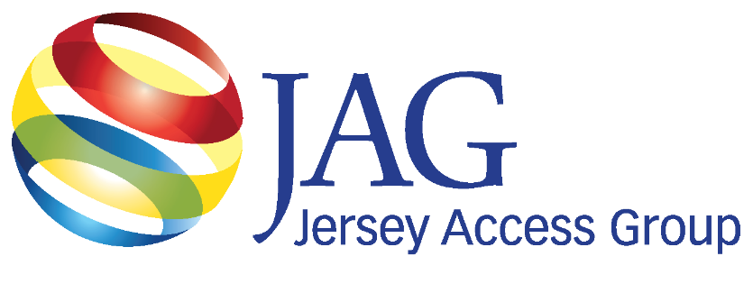Augustatand To rrgPa

***Newsletter***

november 2024

Volume 11, Issue 11

**Trustees 2024**

**Bob Duthaler President – 2026**

**Doug Seidel VP – 2024**

**Linda Besink Treasurer– 2026**

**Rick Gearhart Secretary – 2024**

**Stephanie Gibbons Corresponding Sec. – 2025**

**Dave Garb – 2024**

**George Fairfield – 2026**

**Don Smith – 2025**

**Mark Albala – 2025**

**Inside This Issue**

**The Session at the NJLM Conference: How Your Town Can Access Federal Broadband Improvement Funds pg3**

**Spotlight: Connecting Communities with JAG: The Power of Media pg5**

**Communications pg6**

**General Meeting**

**Schedule 2024-25**

**Dec. 4 - Cranford TV**

**No presentation**

**Jan. 29, 2025 - Oakland TV**

**Reorganization**

**Presentation - TBA**

**Feb. 26 - Bloomfield TV**

**Presentation - TelVue**

**Mar. 26 - Montclair TV**

**Presentation - TBA**

**Apr. 30- Oradell TV**

**Presentation - DeSisti**

**May 14-15 - Crown Plaza, Edison**

**JAG Annual Conference:**

**Day 1: A Technology Forum**

**Day 2: Management Symposium**

**& The JAG Awards**

**Jun. 25- North Brunswick TV**

**Presentation - TBA**

**Sept. 24 - Varto Technologies**

**Presentation- TBA**

**Oct. 29 - TBA**

**Presentation - TBA**

**Dec. 3 - TBA**

**Presentation - TBA**

**FOLLOW US ON:**

[](https://www.facebook.com/pegtv) [](https://www.instagram.com/jersey_access_group/) [](https://www.linkedin.com/company/jersey-access-group/) [](https://www.youtube.com/channel/UCmA3j3MeNeEjN5WkZarVilQ)

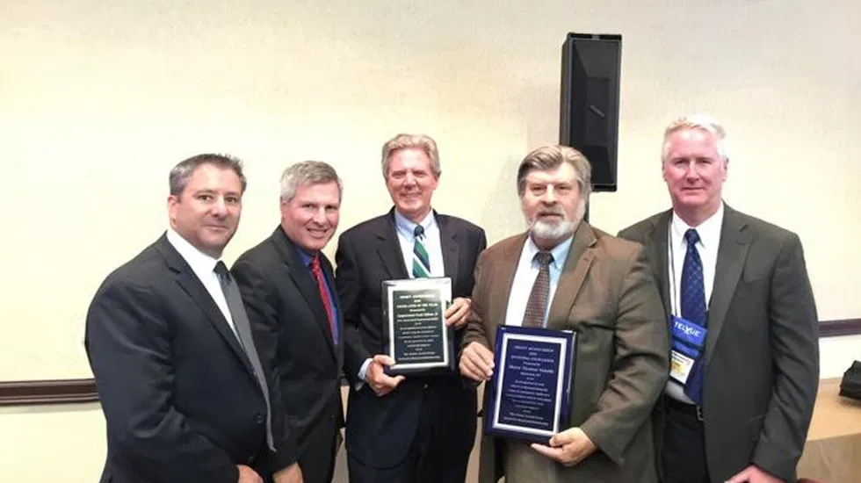**President’s Message**

**Bob Duthaler**

**Holiday: A Time of Reflection and Thanks**

As we approach the close of another year, I find myself reflecting on all that we’ve accomplished together here at the Jersey Access Group (JAG). November is always a special time to pause, take stock of our progress, and appreciate the collective efforts that have shaped this vibrant community. It’s also an opportunity to look ahead—filled with renewed energy and commitment—to continue the important work we do.

Looking back on 2024, it’s clear that this year has been one of growth, adaptation, and connection. We've seen our organization evolve in meaningful ways, strengthening the resources and tools available to our members, and positioning ourselves to have an even greater impact in the future. It hasn’t been without its challenges, but the perseverance and dedication of our JAG community have been unwavering. Together, we've worked diligently to enhance the accessibility and quality of public access media, and I'm proud that we've made significant strides in this area.

One of the milestones of this year has been our expanded training and professional development opportunities. Through the growth of our webinar series, we've been able to reach more members across the state, offering guidance on everything from content creation to the intricacies of media law. In addition, after a period of remote-only events, it was so gratifying to bring back in-person gatherings. These face-to-face events have provided valuable opportunities for networking, skill building, and idea sharing. Our return to in-person events has proven just how much we all value the connections that happen when we come together as a community. It’s a reminder that despite the challenges we face in the world of public media, our resilience and passion remain our greatest assets.

Another highlight of 2024 has been our renewed and focused efforts around community engagement. We’ve worked hard this year to strengthen our partnerships with local organizations, government agencies, and media outlets to ensure that public access media continues to serve as a vital bridge between communities and their local governments. The goal is simple: amplify the voices of those who are often unheard and create a platform for individuals to share their stories, concerns, and ideas with a wider audience. From hosting public meetings to supporting grassroots initiatives, we’ve seen firsthand how the power of media can bring about tangible change. It’s heartening to see our collective efforts make a real difference in the lives of the people we serve.

As we move into the final stretch of 2024, there’s no shortage of exciting projects on the horizon. We’re in the process of exploring new partnerships that will bring additional resources, funding, and opportunities for our members. These partnerships aim to expand our training programs, offer new technical support, and provide more avenues for public access stations to thrive. Our advocacy work is also taking center stage, as we continue to press for the sustainability and growth of public access in New Jersey. With the landscape of media constantly evolving, it’s crucial that we advocate for policies that ensure public access media remains a vital resource for all communities. But we can’t do it alone. We need your voice, your ideas, and your continued engagement to help us shape the future of public access media in this state.

One thing that continues to inspire me is the commitment of our members. Whether you’ve been with JAG for years or are just starting out, your contributions—big or small—are invaluable. The success of our mission rests on your passion, your dedication, and your willingness to push the boundaries of what we can accomplish together. We’ve made great progress, but there is so much more we can do. I’m excited about the potential that lies ahead. The work we do is not just about media access; it’s about empowering communities, amplifying voices, and creating positive change. I know that, together, we will continue to make a meaningful difference.

As always, I encourage you to stay engaged with JAG and take advantage of the resources and opportunities available to you. I hope you find this month’s newsletter both informative and inspiring. If you have any suggestions, ideas, or feedback, don’t hesitate to reach out. We are always eager to hear from you and to learn how we can better support you in your work.

As we enter the holiday season, I want to express my deepest gratitude to each and every one of you. Thank you for your continued support, your passion for public access media, and your unwavering commitment to our mission. I wish you all a wonderful Thanksgiving season filled with warmth, connection, and reflection. May this time of year remind us of the power of community and the difference we can make when we work together.

******News from Trenton & Washington, DC Legislation**

**Dave Garb, Legislative Committee Chair**

**League Session:**

***How Your Town Can Access Federal Broadband Improvement Funds***

Federal Broadband improvement money is now being distributed to municipalities. To apply, towns must supply maps of underserved or unserved areas. Once these maps are established, towns may apply for the funds needed to bring broadband to all.

At the 2024 League of Municipalities Conference, JAG co-hosted (along with the League) a session on this important issue to let New Jersey’s municipalities know how they can access these funds. The panel included Gerard Lederer, Attorney at Law from Best, Best & Krieger LLP; Valarry Bullard, Director, Broadband Office NJ BPU; Joseph Rivera, Manager of Broadband Access, NJ BPU; and Robert Boyle, President and CEO of Planet Networks. The session was moderated by Brian Wahler, Mayor of Piscataway.

Mr. Lederer started off by calming concerns people currently have on if New Jersey is already behind. Mr. Lederer related *“Are we behind in giving out the broadband money compared to other states. And the answer is absolutely not. You're exactly on track and in fact New Jersey has been a little bit at the front of the pack. Every time the announcement is made from the NTIA (which is part of the Department of Commerce) the folks the people giving the money out, they have to approve each of the plans first. There was a preliminary plan and then there was a five year plan and on each of those, New Jersey was at the front.”*

He stated that *“we're in the middle of the challenge process now.”* The challenge process began when the federal government created this whole procedure. They knew that both the FCC (Federal Communications Commission) and NTIA (National Telecommunications and Information Administration), and then each individual state would establish the programs, but they wanted to make sure that local governments voices were not lost in that process. Mayor Brian Wahler worked with NJ Congressman Frank Pallone to ensure that states were part of the challenge process.

So states get the money, but they are vulnerable to a challenge from local governments and public interest groups, if in fact the plan doesn't address all unserved, underserved or traditionally left behind communities.

So New Jersey is in the process of that right now. But, what if the map and the program don't match what's happening in your community? It's not their fault. It's ours because we didn’t make the case! If you used any of your ARPA money at all and left some of it unspent, it’s will be lost! It all must be obligated and you must use it by the deadline: 12/31/24.

The BEAD program is the infrastructure program. Its $42.45 billion and $263.7 million are coming to New Jersey now. That ratio doesn’t sound right, but New Jersey in a lot of ways is being punished for having done its job correctly. This number was based upon the number of unserved locations that were found in each state and New Jersey has significantly fewer than most states.

“*New Jersey is a fairly well connected state where we have just about 7% of our households that actually do not have access to devices,”* added Valarry Bullard, Director, Broadband Office NJ BPU. “*That means that when it comes to the technology and access, we are equally connected and we know that's not the case*.”

Ms. Bullard continued *“Beyond that need infrastructure wise, we can get creative. We can do some non-deployment activities, making sure we're focusing on workforce development on education. There are objectives that are needed to make sure everyone's connected. Let's make sure that people have devices and they have the digital skills. Because if you don't know how to use a computer, while we can focus on teaching you that, it doesn't help if you don't actually have one. Or you can have a computer, but it doesn't help if the infrastructure is not there.”*

The FCC gives you the map and tells you how much funding you have. But then they come back and determine where that funding can be spent at the local level. The process was started, and the messages went out to make sure everyone's aware of just how this program is going to work. Understanding that you have the ties to your communities, nonprofits, and utilities to help identify and spread that word.

So we're in this process now. All responses need to be submitted by 12/31/24 and then we have our final determination. It's not until this entire process is done in February that we will have our final map.

Next, Joseph Rivera, Manager of Broadband Access, NJ BPU, remarked that *“We want to make sure that digital equity means a goal of every resident having the confidence and competence to harness the power of the Internet devices and digitally accessible services. Digital equity can help New Jersey bridge economic and achievement disparities among all residents and enabling them to lead fulfilling lives with dignity. What we're planning to do is help people access affordable, high speed Internet and give people efficient, effective digital experiences with confidence and competence in accessing devices.”*

We're doing a lot of things to ensure that we've reach out to different agencies and see where their needs are, where they're covering populations, how they're affecting the covered populations that they represent. But we also want to do this community of practice. Mr. Rivera continued by commenting on how they are going to put more committees together. They want to make the state websites more accessible and visit more towns because they want to hear from everyone.

President and CEO of Planet Networks, Robert Boyle rounded out the session by suggesting how municipalities, providers and community organizations can help this process. *“So, one of the things that we need to do with this big money is to make sure that it is spent in areas where it's needed, where people are underserved. First thing is providing access to New Jersey broadband offices, the BEAD challenge portal and registering using* [*register.broadband.nj.gov*](http://register.broadband.nj.gov)[*.*](http://www.apple.com) *Remember, they don't know every street in your municipality and they don't specifically know which areas are served and which areas are unserved they only have, a general idea from the FCC's database.*

*You may need to challenge the addresses that show an area is already served, that are not actually being served. This allows the Broadband Office to allocate funds to provide service at that address. Also, you must challenge addresses that show as underserved, but are actually served. You don't want money to go into things where there's already service instead using that money in the places where they really need it.”*

To reiterate, the onus is now at the state and governments levels. the goal is to ensure everyone is accounting for not just where those needs are, but also to ensure that the faces behind these funds are being carefully considered and know where to get help. We have until 12/31/24 to make this happen!

JAG (Jersey Access Group) is an organization that advocates, promotes, and preserves the right to media production, distribution, civic engagement, and education in support of diverse community voices, through Public, Educational and Government access facilities and other forms of media. JAG continues to help its communities stay informed about these infrastructure projects.

**Connecting Communities with JAG Members Spotlight**

**The Power of Media**

**John Morley, Independent Producer**

In my journey through various projects, I’ve always believed in the transformative power of media to connect people, foster understanding, and share stories that truly matter. From my earliest endeavors, it became clear that meaningful communication can bridge gaps, spark dialogue, and inspire action. When I discovered JAG’s mission—supporting local communities and preserving access to critical public information—it immediately struck a chord with me. JAG’s steadfast commitment to public, educational, and government (PEG) media aligns perfectly with my passion for creating platforms that amplify diverse voices and foster a sense of unity.

My introduction to JAG happened during a visit to the Oakland TV Group in Oakland, NJ. There, I was not only introduced to their mission, but also witnessed the tangible impact of PEG media on the community. As a content creator submitting to PEG channels, the Oakland TV Group’s team encouraged me to join JAG, highlighting how it could deepen my involvement and enhance my contribution to promoting local media initiatives.

The importance of local media cannot be overstated. It serves as the glue that holds communities together, shaping how they learn, interact, and grow. For nearly eight years as a member of The International Press, I’ve had the honor of engaging with diverse audiences, uncovering compelling stories, and delivering narratives that inspire and motivate. My approach to journalism is grounded in the pursuit of truth. Before my pen hits paper or my camera rolls, I ensure that every fact is thoroughly vetted and every perspective considered. In a media landscape where sensationalism often reigns, with the mantra “if it bleeds, it leads” dominating headlines, I’ve committed myself to champion a different narrative—one that uplifts, instills hope, and encourages people to live their best lives.

JAG is much more than a repository of media resources; it’s a dynamic collective of passionate individuals who are actively shaping the future of local communication. I recently attended my first live JAG meeting, and the experience was nothing short of inspiring. The enthusiasm and dedication of the members were evident. Their collective energy demonstrated a clear commitment to making a meaningful impact on their communities. During the meeting, the president posed an important question: “What would you like to see from JAG in the coming year?” This sparked a lively discussion, with members quickly brainstorming ideas. One standout suggestion was increasing youth involvement in JAG’s initiatives. In real-time, plans were set in motion to engage a local youth organization—a testament to JAG’s proactive and action-oriented approach.

Through my work, I’ve seen firsthand how local media can empower individuals and bring communities closer together. It’s a platform that elevates unheard voices and sheds light on stories that might otherwise go unnoticed. This is why I’m so excited about the opportunity to collaborate with JAG. Together, we can amplify the impact of local media and continue to foster stronger connections within our communities through accessible, engaging, and inspiring content.

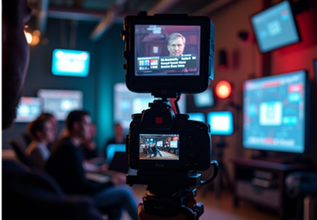As a serial entrepreneur, national talk show host, journalist, and video producer, I’ve worn many hats—and continue to do so. Reflecting on my journey, I could never have imagined that starting my first company over 31 years ago would set the stage for a lifelong serial entrepreneurial path. My focus has always been on solving challenges—whether by launching innovative business ventures or creating impactful media content. Today, as the host of Inspirations for Your Life, a daily talk show with over 175,000 downloads, and The JMOR Tech Talk Show with close 15,000 downloads I am privileged to share powerful insights that help individuals unlock their full potential. My content is widely shared by schools and cable stations, offering a blend of value, truth, and inspiration with the power to transform lives.

If you, too, are passionate about the power of media to create positive change and want to elevate your own life and the lives of others, I invite you to visit [believemeachieve.com](http://believemeachieve.com/). There, you’ll find a wealth of motivational content and insightful nuggets designed to inspire growth and success. Much of this content will become available on the JAG server soon. I hope you will be able to add it to your program line up.

**

**JAG General Meeting**

**December 4, 2024 @ 12:00pm, Cranford TV35, Lunch at 11:30am**

**No Presentation**

**For more information and access to the meeting email** [**JAGinfo@jagonline.org**](mailto:JAGinfo@jagonline.org)

**Don’t forget to check out our YouTube channel. <https://www.youtube.com/@jagjerseyaccessgroup>**

Have something you want on our YouTube channel? Send a link to [**dseidel@piscatawaynj.org**](mailto:dseidel@piscatawaynj.org) for review.

**The JAG Job Board is currently being populated with opportunities. New password needed after June 1. Contact Linda Besink** [**lbesink@gmail.com**](mailto:lbesink@gmail.com) **for access**

**Share the value of JAG’s newsletter with your elected officials, cable committee, station volunteers, associates and friends. Send this invitation:** [**https://lp.constantcontactpages.com/su/B7EMU1R/JAGnewsletter**](https://lp.constantcontactpages.com/su/B7EMU1R/JAGnewsletter)

**EVENT SCHEDULE 2024-25**

**Jan. 29th at 12pm: General Meeting, Oakland TV, Presentation scheduled TBA**

**Feb. 26th at 12pm: General Meeting, WBMA TV Bloomfield, Presentation scheduled TelVue**

**Mar. 26th at 12pm: General Meeting, Montclair TV34, Presentation scheduled TBA**

**Apr. 30th at 12pm: General Meeting, OPTV, Oradell, Presentation scheduled DeSisti**

**May 14th  & 15th: JAG Annual Conference, Crowne Plaza Hotel, Edison**

**Jun. 25th at 12pm: General Meeting, North Brunswick TV15, Presentation scheduled TBA**

**Organizational Members**

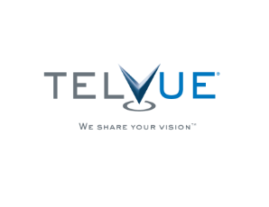



**Jersey Access Group, PO Box 164, Metuchen, New Jersey 08840**

[**www.jagonline.org**](http://www.jagonline.org)[**JAGinfo@jagonline.org**](mailto:JAGinfo@jagonline.org)

**New Jersey Chapter of NATOA, Organizational Member of the ACM, and New Jersey League of Municipalities Affiliate**

**Editor-in-Chief: Rich Desimone Feature Editor: Betsy Schwartz**

**Staff: Bob Duthaler, Geoffery Belinfante, Dave Garb**

Jersey Access Group

[**facebook.com/pegtv**](https://www.facebook.com/pegtv)[**linkedin.com/company/jersey-access-group**](https://www.linkedin.com/company/jersey-access-group/)[**instagram.com/jersey_access_group**](https://www.instagram.com/jersey_access_group/)