
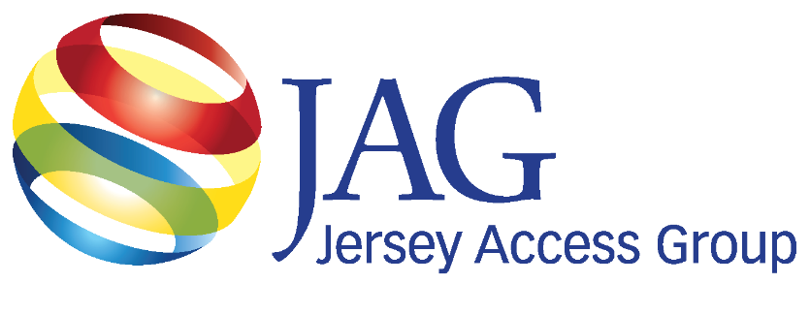
LightinAugustatand To rrgPa
Newsletter

June 2025

Volume 12, Issue 5
Trustees 2024
Bob Duthaler President – 2026
Doug Seidel VP – 2027
Linda Besink Treasurer– 2026
Rick Gearhart Secretary – 2025
Stephanie Gibbons Corresponding Sec. – 2025
Dave Garb – 2027
George Fairfield – 2026
Don Smith – 2025
Mark Albala – 2027
Inside This Issue
News from Trenton & Washington, DC & Changes to the FCC pg3
Reflecting on My First JAG Conference: A Partnership Born
from Shared Purpose pg5
What the Sheraton Implosion Teaches Us About Storytelling in Real Time pg7
Manalapan Township upgrades our PEG channels to the 21st Century pg9
Communications pg11
General Meeting
Schedule 2024-25
Jun. 25- Zoom Meeting
No Presentation
Sept. 24 - TBA
Presentation- TBA
Oct. 29 - TBA
Presentation - TBA
Dec. 3 - TBA
Presentation – TBA
Jan. 28, 2026 - TBA
Reorganization
Presentation – TBA
Feb. 25 - TBA
Presentation – TBA
Mar. 25 - TBA
Presentation – TBA
Apr. 30 - TBA
Presentation – TBA
May 14 - TBA
Presentation – TBA

FOLLOW US ON:

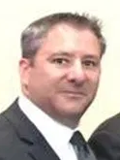
President’s Message
Bob Duthaler, President of Jersey Access Group

Summer Strategy: What’s Yours?
As summer sets in, many of us naturally start thinking about vacations, community events, and a slightly slower pace. While it’s important to take some time to recharge, the summer months also offer a valuable opportunity for JAG members and stations to look ahead, plan strategically, and strengthen both their operations and community engagement. Here are a few key areas every member station should consider focusing on this summer:

1. Review and Refresh Programming
Summer tends to have a different viewing rhythm. It’s a great time to introduce lighter, more community-driven content—like coverage of local parades, festivals, farmers markets, and summer concerts. Use this time to:
- Highlight community voices and local events
- Rotate in fresh programming or special series
- Re-air popular shows with updated intros or local commentary
- Go live when you can

2. Update Equipment and Systems
Take advantage of the slightly reduced programming demands during the day to assess your technology. Whether it’s upgrading outdated gear, reorganizing your control room, or testing remote broadcasting setups, summer is the perfect time to tackle these projects before both nighttime events and the busy fall season returns:
- Clean out your equipment racks
- Update software and firmware
- JAG’s vendor presentations throughout the year offer insight into new tools. Summer is the perfect time to review those and start planning.

3. Offer Internships and Training
Many students are home for the summer—and eager to gain experience. Create internship opportunities to give back to the community while also increasing your station’s production capacity. It’s also an excellent time to:
- Train your volunteers and staff on new equipment
- Cross-train team members to strengthen operational resilience

4. Strengthen Community Partnerships
Summer is packed with community events—parades, concerts, festivals, and outdoor town meetings. These events are golden opportunities for outreach. Use this time to build relationships:
- Attend town council meetings or community forums
- Meet with local non-profits or schools to develop new partnerships
- Promote your station at outdoor events with booths, giveaways, or live coverage
- Every handshake or question is a reminder to residents that their local PEG station is there for them.

5. Plan for the Fall
Use this time to start planning your fall content, budget, and grant applications. Reconnect with JAG resources—from shared programming to policy guidance. Be proactive in attending upcoming JAG meetings and workshops. Start laying the groundwork for fall initiatives, including:
- Election coverage planning
- Back-to-school content
- Strategic content campaigns or series
- Budgets and grants

6. Tell Your Story
Summer is a great time to work on the behind-the-scenes story of your station. Highlight your team, your history, and your mission on social media and in your programming. JAG members do incredible work—don’t forget to showcase it.

7. Engage with JAG Resources
Don't forget: JAG is here to support you. Over the summer, stay connected:
- Revisit virtual meetings and workshops
- Share best practices with fellow members
- Reach out to fellow members and the board if you need guidance on technical or policy matters

Final Thoughts
Summer is not just a break; it’s a bridge. It connects what we’ve accomplished in the first half of the year to what’s ahead. Use this time to innovate, collaborate, and prepare. Whether you’re upgrading your gear, covering a summer concert, or mentoring a future media professional, your station plays a vital role in connecting and informing your community.
Stay cool, stay creative—and stay connected with JAG.

Sincerely,

Bob Duthaler
President, Jersey Access Group

News from Trenton & Washington, Legislative Committee
DC and FCC Legislation Changes
Dave Garb, Legislative Committee, Chair

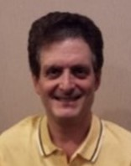
It’s Back! The Protecting Community Television Act, S-1994 / HR-3805

From the Press Office of Massachusetts Senator Edward Markey:
Senators Markey and Baldwin, and Representative Carter have announced legislation to protect public television channels.
On June 5, 2025, Senator Edward J. Markey (D-MA.), a member of the Senate Commerce, Science, and Transportation Committee, Senator Tammy Baldwin (D-WI), and Representative Troy A. Carter Sr. (LA-02), member of the House Energy & Commerce Committee, announced the introduction of the Protecting Community Television Act, S-1994 and HR-3805. This legislation would undo rulemaking from the first Trump administration’s Federal Communications Commission (FCC) that effectively limited the resources available for public, educational, and government (PEG) channels.
Under the Communications Act, cable companies negotiate franchise agreements with local governments to provide cable services in a community. The Act caps franchise fees that a cable company pays to the local government at 5% of its revenue. This revenue helps fund PEG stations, as well as other community services such as public libraries and emergency responders. In addition, cable companies historically paid up to 5% cap and provided additional in-kind support to the community, such as free cable service to schools or access to building studios.
In 2019, the FCC issued a new rule that counted those in-kind contributions towards the 5% cap, meaning cable companies could reduce their cash payments by claiming the value of those services. With fewer cash resources, local governments were forced to choose between investing in PEG programming or supporting other public services. The result has been less funding for PEG stations.
“Millions of Americans rely on community television to keep up with the news that matters most to them, stay plugged into enriching, educational programming, and hold their local governments to account. But, the Trump administration forced communities across the country to pull the plug on public programming,” said Senator Markey. “At a time when news and media have become more consolidated than ever before, I am proud to partner with Senator Baldwin and Representative Carter to reintroduce the Protecting Community Television Act to uphold local access to public, education, and government channels for every household in our country.”
“I’m proud to cosponsor this bill and stand with communities that depend on local media to stay informed, connected, and heard. PEG channels are lifelines for civic engagement and public education, especially in times of crisis, and they shouldn’t be collateral damage in a corporate accounting maneuver. This legislation restores the original promise Congress made: that local governments should have the tools they need to meet community needs without being forced to choose between vital services and local voices,” said Congressman Carter.
The legislation has been endorsed by Senate Democratic Leader Schumer (D-NY), and Senators Cory Booker (D-NJ), Richard Blumenthal (D-CT), Mazie Hirono (D-HI), Angus King (I-ME), Amy Klobuchar (D-MN.), Jeff Merkley (D-OR), Chris Murphy (D-CT), Bernie Sanders (I-VT), Brian Schatz (D-HI), Jeanne Shaheen (D-NH), Tina Smith (D-MN), Elizabeth Warren (D-MA), Peter Welch (D-VT), Ron Wyden (D-OR), Kirsten Gillibrand (D-NY), Chris Van Hollen (D-MD), and Alex Padilla (D-CA).
The Protecting Community Television Act is also endorsed by the Alliance for Community Media, the National Association of Counties, the National Association of Telecommunications Officers and Advisors, National League of Cities, MassAccess, and Maine Community Media Association.
“The Alliance for Community Media welcomes the re-introduction of the Protecting Community Television Act and wants to thank Senator Markey and Representative Carter for their support for community access television. Passage of the Act will reduce fees that drain away monetary support for local community media channels across the country. At a time when we have fewer and fewer local journalists and reliable local information sources, cities and towns need community access television more than ever, and this bill will help sustain our operations,” said Mike Wassenaar, President & CEO, Alliance for Community Media.
“Counties rely on public communications channels to disseminate local news and updates to residents in a timely manner,” said Matthew Chase, Executive Director of the National Association of Counties. “By preserving monetary support for public, educational and government channels through franchise fees, counties would ensure that essential local content remains accessible to residents. Counties thank Senators Ed Markey and Tammy Baldwin for introducing the Protecting Community Television Act and urge its swift passage”
“The Protecting Community Television Act (PCTA) is elegant legislation that seeks to protect benefits consistent with the Cable Act and cable franchising principles since 1984. In 2019, the Federal Communications Commission issued an order that undermines this ability by redefining the term “franchise fees” as used in the Cable Act and substituting its definition for that written by Congress in 1984. The Protecting Community Television Act remedies that altered meaning by protecting local public, educational and community access television so folks in communities across the country can continue to access relevant and timely local news that they rely on. Thanks to Senators Ed Markey (D-MA) and Tammy Baldwin (D-WI) and Congressman Troy Carter (D-LA) for continuing to advocate for the PCTA, which reaffirms Congress’ original intent to protect the long-standing ability of local governments to manage public property and provide for local media through public, educational and governmental access channels (PEG access) in cable franchise agreements,” said Mike Lynch, Legislative Director for National Association of Telecommunications Officers and Advisors.
In the next couple of weeks, the legislative committee will be reaching out to New Jersey’s leadership in Washington, to ask for their support in co-sponsoring this Act.
Shake-up at the FCC
On June 4th, FCC Commissioner Nathan A. Simington announced his resignation from the Commission. Around the same time Commissioner Geoffrey Starks also resigned. This now leaves the commission with only two commissioners, one democrat and one republican. This may cause difficulties in getting things voted on or changed until another commissioner is confirmed.
However, it may also be short lived. On April 30th, the Senate Committee confirmed republican nominee Olivia Trusty by a vote of 21 to 7 as an FCC Commissioner. She is now waiting for her nomination to go to the floor of the full Senate for a final vote.
Ranking members Senator Cantwell (D-WA), Senator Klobuchar (D-MN), and Sen Rosen (D-NV) all said they support reporting Trusty favorably out of the Committee upon a representation that the full Senate will move Democratic replacements. More will be coming on this in the next few weeks.
JAG (Jersey Access Group) is an organization that advocates, promotes, and preserves the right to media production, distribution, civic engagement, and education in support of diverse community voices, through Public, Educational and Government access facilities and other forms of media.
Reflecting on My First JAG Conference: Organizational Member
A Partnership Born from Shared Purpose
Rudy Ellis, CEO, Switchboard Live


As JAG’s newest member, Switchboard Live's attendance at the 25th JAG Conference was both an introduction and a homecoming. Walking into that conference as an exhibitor, partner, and attendee, I wasn't entirely sure what to expect. But, what I discovered over those two transformative days was a community that embodies everything we believe in at Switchboard Live—the power of genuine connection, purposeful technology, and unwavering dedication to amplifying voices that matter.
This Isn't Just Another Industry Group
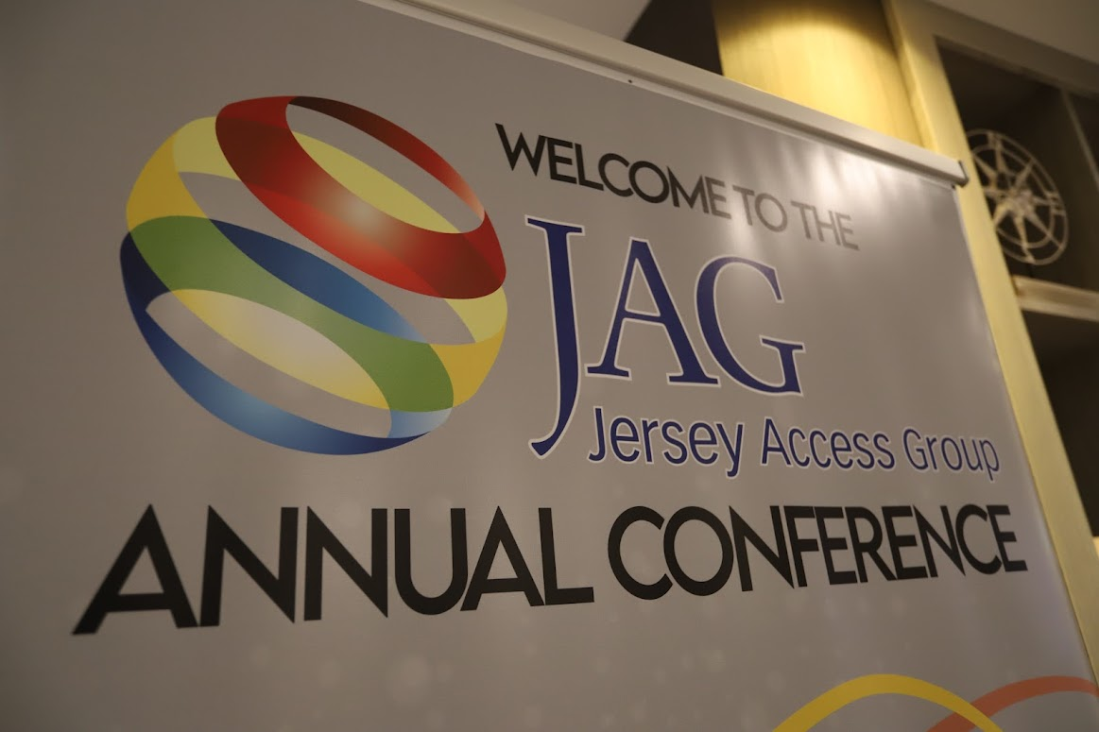
One of the most profound aspects of my conference experience was learning about JAG's rich history and the passionate individuals who built this organization from the ground up.
Listening to the founding members speak at the awards dinner, I was struck by their dedication to what is truly "a passion and a thankless job."
Whether serving as a JAG member or working as a team member at a station, everyone I met shared this underlying commitment to community television and its vital role in our society.
The core philosophy I took away—"accomplishing great with less"—resonates deeply with Switchboard Live’s mission, especially in today's challenging funding environment. With year-over-year PEG funding dwindling, the need to do more with less has never been more critical. This reality underscores the resourcefulness and determination that defines both our communities and our approach to empowering communication teams with technology that simplifies their work while amplifying their voice.
The Power of Purposeful Partnerships
The partner dinner was particularly eye-opening. Seeing how valuable partnerships have grown to support JAG members and their initiatives reinforced why we chose to become part of this community. It's not just about vendors selling products—it's about creating meaningful connections between organizations that share common goals and values.
As someone new to the JAG community, I quickly realized that partnerships here are built on genuine need and mutual support. Stations face real challenges in their mission to serve their communities, and partners like Switchboard Live exist to provide solutions that truly make a difference.
My Surprising Booth Presentation
Perhaps the most rewarding part of the conference was my booth demonstration. As the newcomer in the block, I knew we had work to do in helping people understand where Switchboard Live fits in the ecosystem, the value we bring, and how we complement the partners they already know and trust.
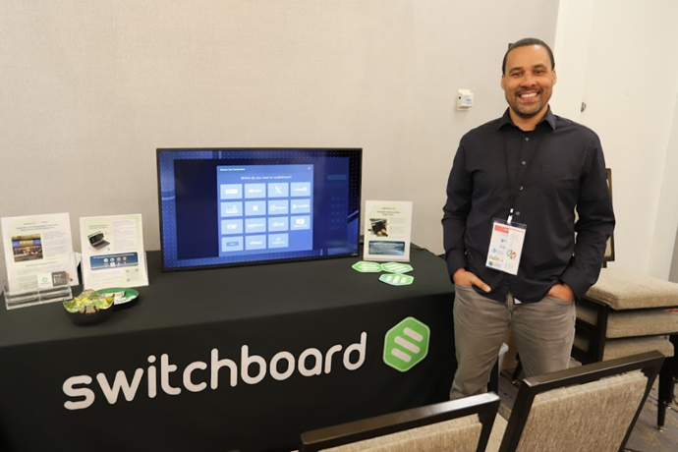
What happened exceeded my expectations. I expected maybe a few polite listeners, but during the demo, I found myself surrounded by 15-17 engaged attendees for nearly fifteen minutes—station managers, team members, and fellow vendors all genuinely interested in understanding how Switchboard Live could support their work. The questions were thoughtful, the discussions were substantive, and the interest was authentic.
This experience perfectly captured what makes JAG a community. These are people who are genuinely invested in finding better ways to serve their audiences and support their missions. They don't just attend conferences to go through the motions—they're actively seeking solutions, partnerships, and connections that will help them do their jobs better.
Looking Forward: Building on Shared Mission
Our goal at Switchboard Live has always been to surround ourselves with communities that support our cause and mission of empowering communication teams with technology that simplifies their work while amplifying their voice. The JAG community is exactly that—a group of passionate professionals who understand that behind every piece of technology is a person trying to do meaningful work.I'm excited about the partnerships we're building and the conversations that have continued beyond the conference.
To the teams at Woodbridge Township and East Brunswick who received our door prize gifts: I hope you will find them useful and we can't wait to hear about your experience.
For fellow JAG members considering new solutions, I encourage you to reach out to these stations to hear firsthand about their experience with both our platform and our support. We understand that when you're presenting new technology solutions to leadership, the quality of ongoing support can make or break your success as a leader—and we're committed to ensuring that support never becomes a concern.
Let’s Keep The Conversation Going
For those I haven't had the chance to meet yet, I'm Rudy, and I represent Switchboard Live as we grow our presence in the JAG community. Our platform helps streamline workflows and enhance audience connections, but honestly, I'm more interested in understanding your specific challenges first. You can reach me directly at rudy@switchboard.live and learn more about our solutions by visiting https://switchboard.live .
I believe the best partnerships are built on conversation and understanding. Whether you're curious about what we do, have questions about how technology can support your station's mission, or simply want to connect with a fellow JAG member, I'd welcome the opportunity to talk.
The 25th JAG Conference reminded me why we do this work—not just for the technology, but for the communities we serve and the voices we help amplify. I'm grateful to be part of this organization and look forward to contributing to its continued success.
What the Sheraton Implosion Teaches Us Tech Talk
About Storytelling in Real Time
John C. Morley—Independent Producer

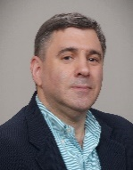
Through the Lens of Legacy: What the Sheraton Mahwah Implosion Taught Me about the Art of Storytelling and Media Mastery
On a cool morning in northern New Jersey, I stood among a crowd of early risers, camera in hand, as we prepared to witness something extraordinary. The air was heavy with anticipation. And then, in a matter of seconds, the iconic Sheraton Mahwah Towers—once a symbol of luxury and architectural pride—collapsed in an astonishing display of precision demolition.
But this wasn't just a building falling to the ground. It was the end of an era, the punctuation mark on decades of memories. As I stood there, absorbing both the spectacle and the significance, I realized this moment held valuable lessons—not only about history, but also about the craft of storytelling and the responsibility that comes with documenting transformative events.
The Rise and Fall of a Landmark
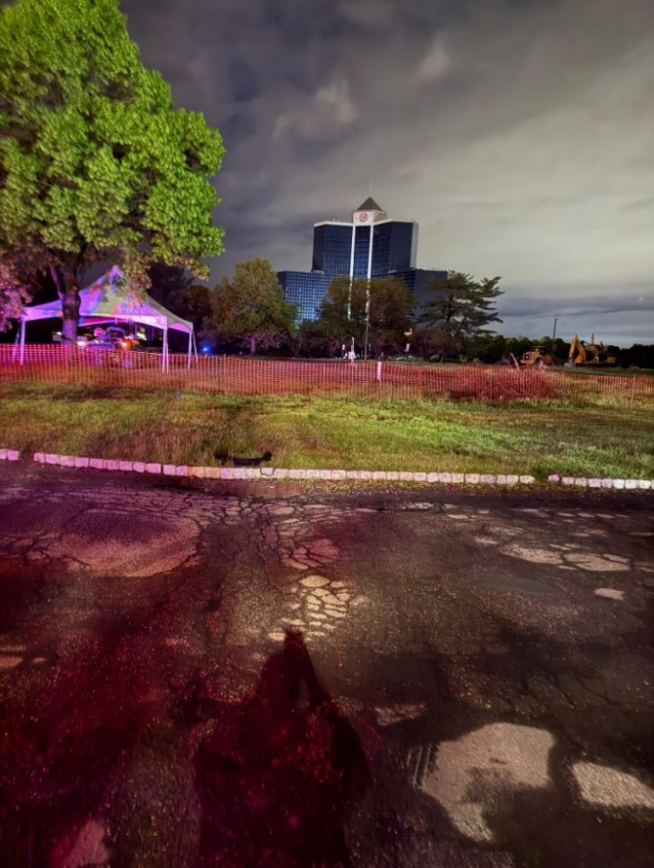
The Sheraton Mahwah wasn’t just a hotel. Opened in 1987, it stood for over three decades as one of Bergen County’s most distinctive structures. With its mirrored glass towers and sweeping mountain views, the hotel was an architectural icon, well-known to locals, travelers, and even corporate clients who hosted meetings, weddings, and conferences there, including my High School Junior Ring Dance.
Over time, the once-bustling Sheraton began to lose its luster, its decline accelerated by a series of minor earthquakes that quietly compromised the building’s integrity.
As the years passed and its halls fell silent, vacancy gave way to visible decay. What had once been a gleaming landmark became a ghost on the skyline. Ultimately, the decision was made: demolition was inevitable.
But, the implosion that followed wasn’t merely a feat of engineering; it was a powerful cultural moment. For the community that had celebrated milestones (including my own High School Junior Ring Dance) under its mirrored towers, this was the end of a chapter and the beginning of remembering.
The Science Behind the Spectacle
What appeared to be a moment of sudden destruction was, in reality, the result of months of careful planning and engineering. More than 1,700 explosive charges were strategically installed throughout the towers. Engineers studied the structure’s weak points, calculated the timing of the collapse, and carefully coordinated every detail to ensure the towers would fall inward safely and efficiently.
In less than 20 seconds, years of design and history were brought down in a perfectly executed sequence. What fascinated me wasn’t just the power of the explosion, it was the elegance of the execution. It reminded me that just like storytelling, controlled demolition is all about timing, structure, and intention.

The Hidden Work Behind a Great Media Shoot
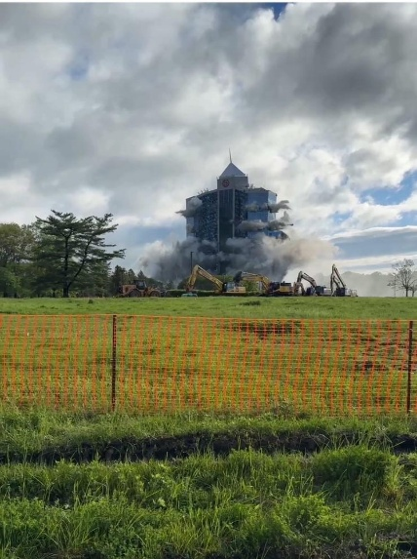
While the implosion itself lasted only seconds, my preparation for capturing it began long before that. That’s where the real parallel lies for media professionals. Successful storytelling (especially in dynamic, one-shot environments) requires more than just showing up with a camera.
I arrived hours in advance to scout angles, evaluate lighting conditions, anticipate crowd movement, and plan my gear setup. I brought backups of everything: batteries, lenses, memory cards. I mapped out audio strategies, knowing that the sound of the collapse (the boom, the crowd’s reaction…) would be just as vital as the visuals.
You can’t afford to fumble in moments like this. There are no second takes. The same principle applies whether you’re covering an implosion or interviewing a community leader. Being unprepared isn’t just inconvenient—it’s disrespectful to the story you’re trying to tell.
Capturing Legacy, Not Just Footage
As the dust cloud enveloped the skyline and the last echoes of the collapse faded, I realized this was about more than visuals. This building had witnessed thousands of life events: celebrations, farewells, and new beginnings. For some, the Sheraton was where they got married. For others, it was where their careers took a major turn. I wasn’t just recording a building’s destruction. I was honoring its life.
That’s what makes storytelling a privilege. We’re not merely documenting change, we’re preserving history, identity, and emotion. That takes more than technical skill. It requires empathy, foresight, and a deep respect for the subject at hand.
Lessons from the Rubble
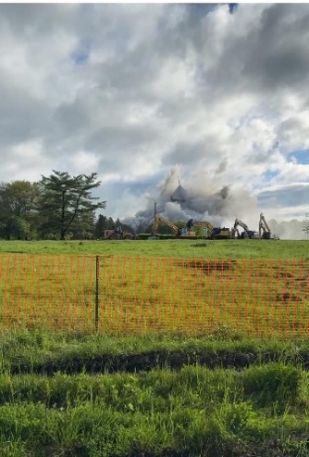
The implosion left more than broken concrete in its wake. It left me with a set of lessons that apply to every media professional, content creator, and storyteller:
- Moments are fleeting. If you’re not prepared before they happen, you miss them entirely
- Preparation is not optional. It’s an act of respect for the people, the place, and the event
- Great storytelling comes from intentionality. Every frame, every sound, every detail has a purpose
There’s also something humbling about watching a once-mighty structure fall. It reminds us of the impermanence of even the most solid-seeming things. That’s why our role as storytellers is so important. We don’t just record what happened, we give it meaning, context, and a place in collective memory.
Final Thoughts
The fall of the Sheraton Mahwah Towers was more than a media assignment. It was a masterclass in planning, storytelling, and presence. It was a rare opportunity to reflect on how we document the world, not just through our equipment, but through the lens of purpose.
Whether you're covering a demolition, a community event, or a quiet moment of personal triumph, never forget you’re not just capturing content. You’re preserving something real, something fleeting, and something that deserves to be remembered well. Remember to be early as when you’re on time you are always late. Talk to projects leaders to give you an inside scoop that will help you build strong supporting legs for your story.
Manalapan Township upgrades our Members Spotlight

PEG channels to the 21st Century
Jan Zachary, Cable Television Coordinator for Manalapan Township

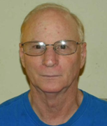
Hi Everyone! Jan Zachary here! I am the Cable Television Coordinator (CTC) for the Manalapan Township Television Network (MTTN) since 2010, after joining the Cable Television Advisory Committee at its inception in 2005. This is my second article for JAG. I wrote another one in October of 2021 and am reporting to you that we now have completely updated with new systems to talk about.
For those of you who are newer members of JAG, I will first discuss some introductory remarks on MTTN. When we formed our ordinances and wrote our policy and procedure manual, the Township Committee informed us that only township events and meetings would be permitted. Only educational and government-sponsored programs would be broadcast on MTTN. We do not accept public programming. We started out with CTC and a program manager. The CTC oversaw the cable station while the program manager organized our volunteers and created content for the station. In 2010, I became the CTC and assumed both functions.
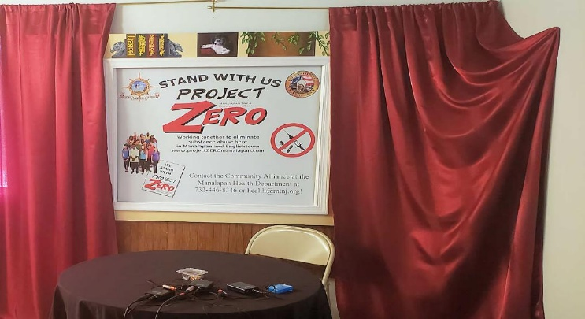
We have a great band of volunteers who help and counsel on innovative ideas relating to Manalapan. All our volunteers, whether on the Cable Television Advisory Committee or just volunteering, must help when they can, by both supporting, setting up and recording our programming.
We work on programs that deal with historical Manalapan such as the Village Inn (1732), the Battle of Monmouth (1778), and the History Fair at Monmouth Battlefield, which is always a major event.
We also broadcast Freehold Regional High School meetings, K-8 regional school meetings, and events. Township Committee meetings and Planning Board Meetings are broadcast LIVE. We also record county and local debates, as well as unique events given by the schools, township, county, and state. We try to cover all events that occur within the boundaries of Manalapan and are relevant to Manalapan.
We operate several outlets. We have Optimum SD (Channel 77), Verizon SD (Channel 42), Verizon HD (Channel 2142), Vimeo, and Facebook. The SD channels run on one server and the HD channel runs on its own server.
Over the last 4 years, we have been negotiating with Optimum on a new contract as well as having discussions with Verizon about adding an HD channel. The results of these negotiations included:
- Verizon agreed to supply us with two channels, SD channel 42 and HD channel 2142. The one stipulation was that each channel should have different daily programs. They did not want complete duplication of each channel.
- On the Optimum side we finished contract negotiations, and they offered us a grant for new equipment. With this grant money we spent the last three years looking for new equipment and with the help of MANY LOCAL VENDORS (all JAG supporters, by the way) we narrowed it down and then made final decisions on what to purchase. All new. All HD.
It only took 15 years to do this…. In January 2025, we finalized with G&G Technology with the purchases of:
- Data Video SE 2600 switcher with adjunctive equipment, including 4 HE PTZ cameras and servicing for events in our courtroom. We have a SE-1200 Data Video switcher we take out on the road.
- Two Tightrope CBL-VIOLITE-700 two channel configurable 1x1 SD/HD SDl encode/decode, multi-format server with 8TB of storage in a 1 RU chassis. Selectable SD or HD SDI with embedded audio that pulls in RTP, RTMP, RTSP, NDI, SRT and HLS streams (including Cablecast Automation, Video and CG server Software. Cablecast CG…..etc.).
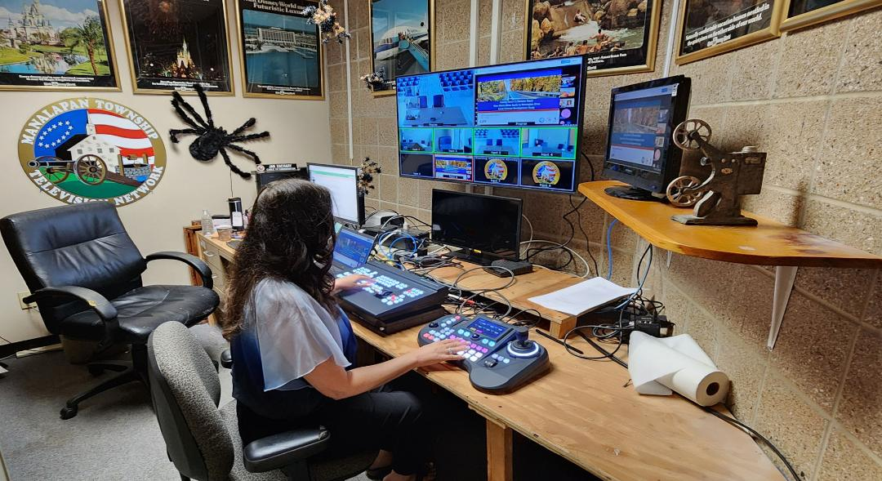
With this setup, we now can broadcast different programming on multiple channels simultaneously. And, it was not that difficult to learn. I would like to thank all the vendors who took a lot of their time helping us get to the end decision. JAG VENDORS ROCK!
Of course, no one can stand alone. Without the cooperation of Manalapan’s Administration and Township Committee we would not be able to achieve our goals to further enhance our television station. We also receive enormous support and help right here at JAG. If something is going on in the legal world or the technical world of PEG then here is the place to seek guidance.
Thank you to all the members of the Jersey Access group! Manalapan Township, A Great Place to Live!

Events and Postings Communications

JAG General Meeting
June 25, 2025 @ 12:00pm, Zoom Meeting
Discussion and evaluation of conference
For more information and access to the meeting email JAGinfo@jagonline.org

Don’t forget to check out our YouTube channel. https://www.youtube.com/@jagjerseyaccessgroup
Have something you want on our YouTube channel? Send a link to dseidel@piscatawaynj.org for review.

The JAG Job Board is currently being populated with opportunities. New password needed after June 1. Contact Linda Besink lbesink@gmail.com for access

Share the value of JAG’s newsletter with your elected officials, cable committee, station volunteers, associates and friends. Send this invitation: https://lp.constantcontactpages.com/su/B7EMU1R/JAGnewsletter

EVENT SCHEDULE 2025
June 25 at 12pm: General Meeting, Zoom Meeting, No presentation scheduled
September 24 at 12pm: General Meeting, TBA, Presentation scheduled TBA
October 29 at 12pm: General Meeting, TBA, Presentation scheduled TBA
December 3 at 12pm: General Meeting, TBA, Presentation scheduled TBA

Organizational Members

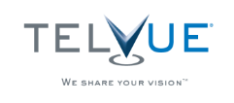

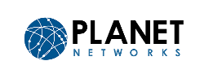








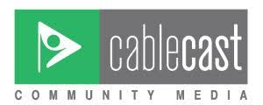


Jersey Access Group, PO Box 164, Metuchen, New Jersey 08840
www.jagonline.org JAGinfo@jagonline.org
New Jersey Chapter of NATOA, Organizational Member of the ACM, and New Jersey League of Municipalities Affiliate
Editor-in-Chief: Rich Desimone Feature Editor: Betsy Robin Schwartz
Staff: Bob Duthaler, Geoffrey Belinfante, Dave Garb, John Morley

Jersey Access Group
facebook.com/pegtv linkedin.com/company/jersey-access-group instagram.com/jersey_access_group

